Project Name:
FCFS AND MEDIAN

Supervised by:
SIR WAQAS AKBER

GROUP MEMBERS:
NAMES | ROLLNO
NAZEEF AFRIDI | 2022F-BCS-185
SYED HANZALA HUSSAIN | 2022F-BCS-286
AHMED MALLICK | 2022F-BCS-154
MUDASSIR ALAM | 2022F-BCS-151

NAMES | TASKS DISTRIBUTION
NAZEEF AFRIDI | 1.Proper Report file.
SYED HANZALA HUSSAIN
MUDASSIR ALAM | 3.Create 1 command using bash scirpting to get median from file data.
AHMED MALLICK | 4.Create 1 flag of above command.

SOURCE CODE:

using System;
using System.Collections.Generic;
using System.ComponentModel;
using System.Data;
using System.Drawing;
using System.Linq;
using System.Text;
using System.Threading.Tasks;
using System.Windows.Forms;

namespace WindowsFormsApp11
{
public partial class Form1 : Form
{
private Data[] data;
struct Data
{
public string process_no;
public int arrival, burst, start, completion, waiting, tat;
}
public Form1()
{
InitializeComponent();
data = new Data[0];
listview();
}
private void listview()
{
LV.Clear();
LV.View = View.Details;
LV.Columns.Add("No of Process", 80);
LV.Columns.Add("Arrival Time", 80);
LV.Columns.Add("Burst Time", 80);
LV.Columns.Add("Start Time", 80);
LV.Columns.Add("Completion Time", 80);
LV.Columns.Add("Waiting Time", 80);
LV.Columns.Add("T.A.T", 80);
LV.GridLines = true;

}
private void btnGenerate_Click(object sender, EventArgs e)
{
Random rnd = new Random();
int arrival, burst;

if (string.IsNullOrEmpty(txtprocessor.Text))
{
MessageBox.Show("Input No of Processor");
}
else
{
for (int i = 0; i < int.Parse(txtprocessor.Text); i++)
{
Array.Resize(ref data, data.Length + 1);
arrival = rnd.Next(1, 30);
burst = rnd.Next(1, 30);

data[data.GetUpperBound(0)] = new Data
{
process_no = "Process - " + (i + 1),
arrival = arrival,
burst = burst
};

ListViewItem item = new ListViewItem(data[data.GetUpperBound(0)].process_no);
item.SubItems.Add(data[data.GetUpperBound(0)].arrival.ToString());
item.SubItems.Add(data[data.GetUpperBound(0)].burst.ToString());
LV.Items.Add(item);
}

txtprocessor.Clear();
}
}

private void btnfcfs_Click(object sender, EventArgs e)
{
listview();
int WT, LE;
string NP;
float total = 0;
for (int i = 0; i < data.Length; i++)
{
for (int j = 0; j < 1; j++)
{
if (data[i].arrival < data[j].arrival)
{
WT = data[j].arrival;
data[j].arrival = data[i].arrival;
data[i].arrival = WT;
NP = data[j].process_no;
data[j].process_no = data[i].process_no;
data[i].process_no = NP;
LE = data[j].burst;
data[j].burst = data[i].burst;
data[i].burst = LE;
}
}
}
for (int r = 0; r < data.Length; r++)
{
if (r > 0)
{
if (data[r].arrival <= data[r - 1].completion)
{
data[r].start = data[r - 1].completion;
}

else
{
data[r].start = data[r].arrival;
}
}

else
data[r].start = data[r].arrival;
data[r].completion = data[r].burst + data[r].start;
data[r].waiting = data[r].start - data[r].arrival;
data[r].tat = data[r].completion - data[r].arrival;
total += data[r].tat;
}
txttotal.Text = total.ToString();
txtavg.Text = (total / data.Length).ToString();
for (int r = 0; r < data.Length; r++)
{
LV.Items.Add(data[r].process_no);
LV.Items[r].SubItems.Add(data[r].arrival.ToString());
LV.Items[r].SubItems.Add(data[r].burst.ToString());
LV.Items[r].SubItems.Add(data[r].start.ToString());
LV.Items[r].SubItems.Add(data[r].completion.ToString());
LV.Items[r].SubItems.Add(data[r].waiting.ToString());
LV.Items[r].SubItems.Add(data[r].tat.ToString());
}

}

private void btnreset_Click(object sender, EventArgs e)
{
txtavg.Clear();
txttotal.Clear();
listview();
}
}
}

WINDOWS FORM:

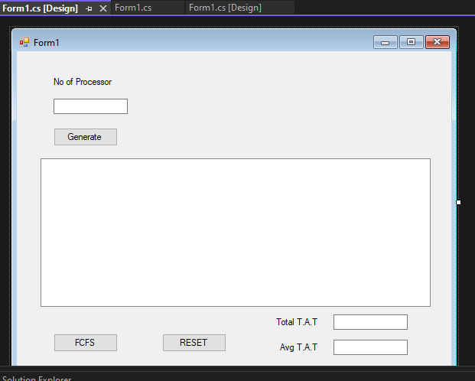

OUTPUT:

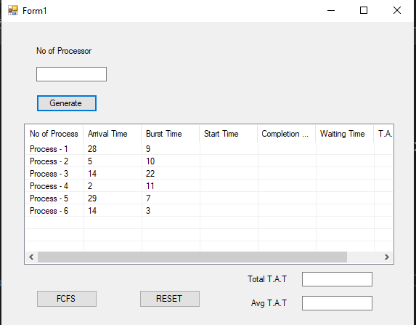
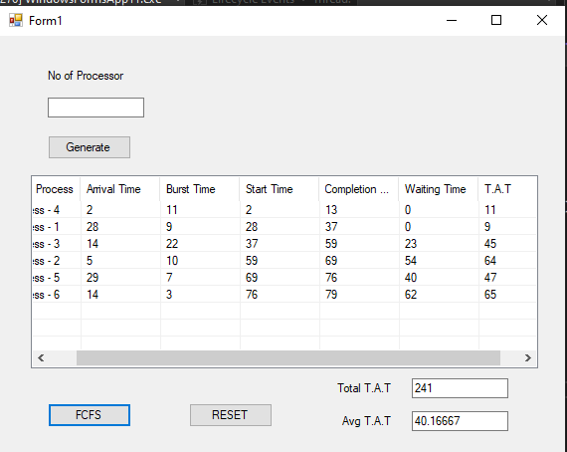
BASH SCRIPTING CODE TO GET MEDIAN FROM THE FILE DATA.

SOURCE CODE:

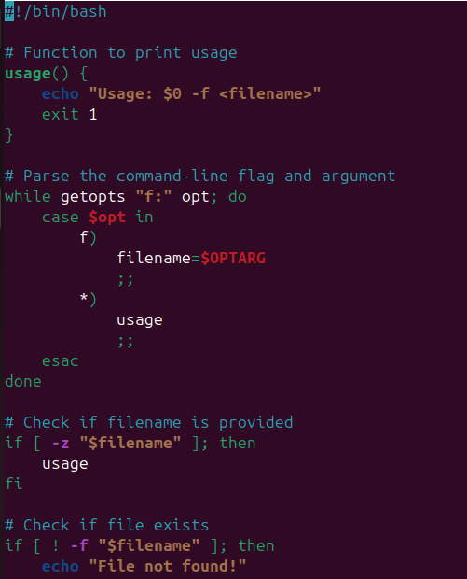
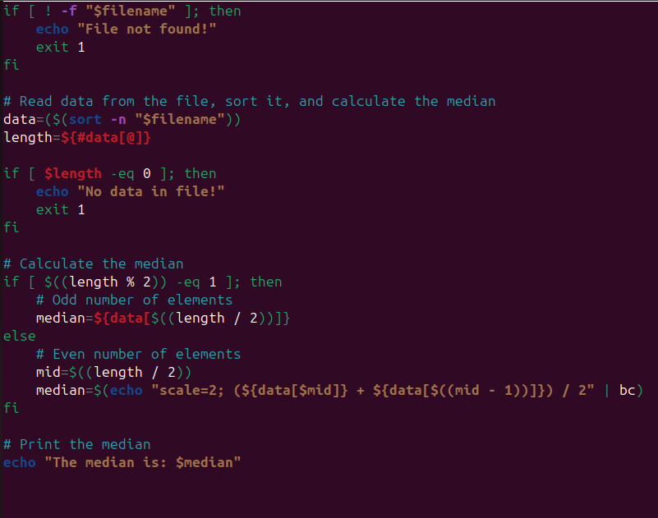

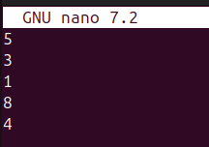

FLAG:

FILE LOCATION:

